EXPERIEMNT:10: Create a simple cloud software application to run a c program to display the student information using any Cloud Service Provider to demonstrate SaaS with the template of student name, Reg no, address, phone, age, courses, grades and attendance report, progress report, Semester mark sheet forms.

STEP:1 CREATE A APPLICATION FORM FOR THE STUDENT DETAILS.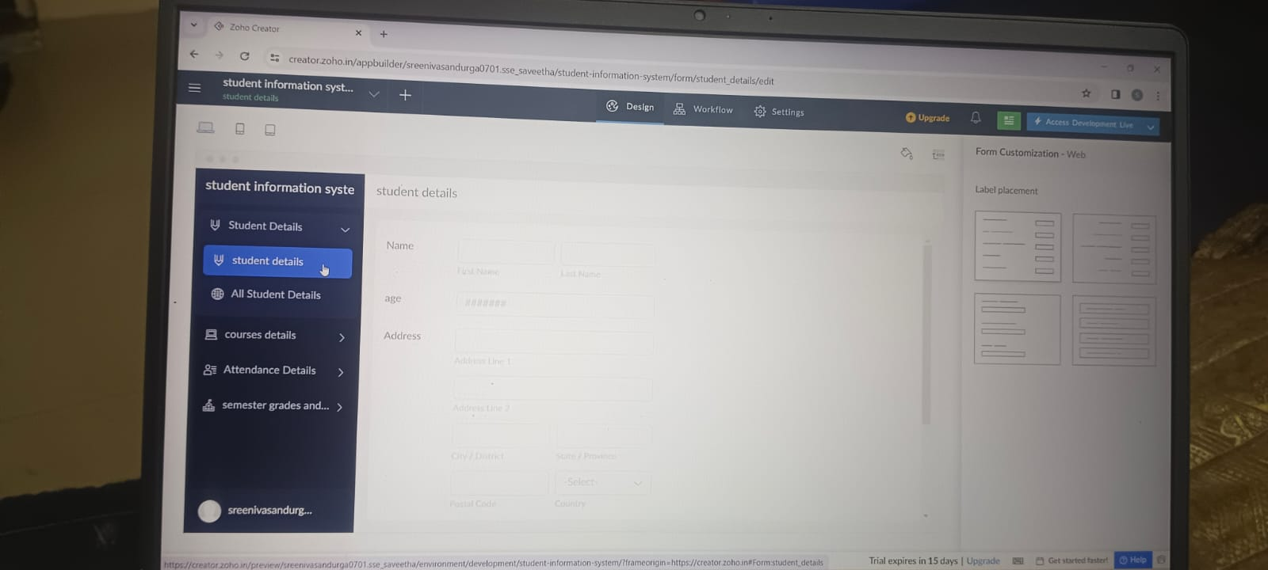

STEP:2: CREATE A APPLICATION FORM FOR THE ATTENDANCE DETAILS.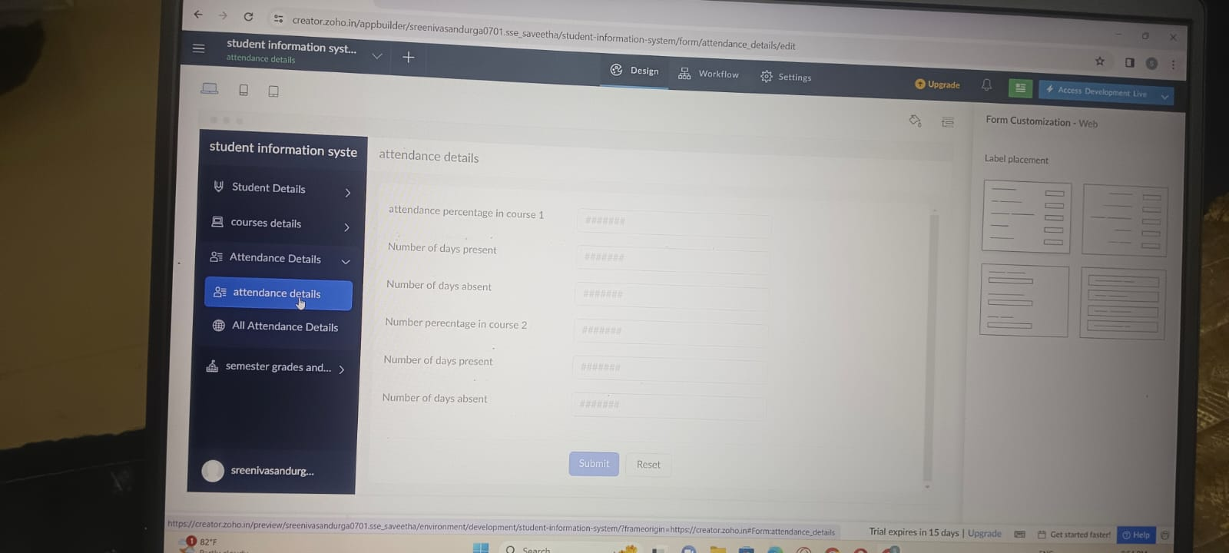

STEP:3: CREATE A APPLICATION FORM FOR THE MARK DETAILS.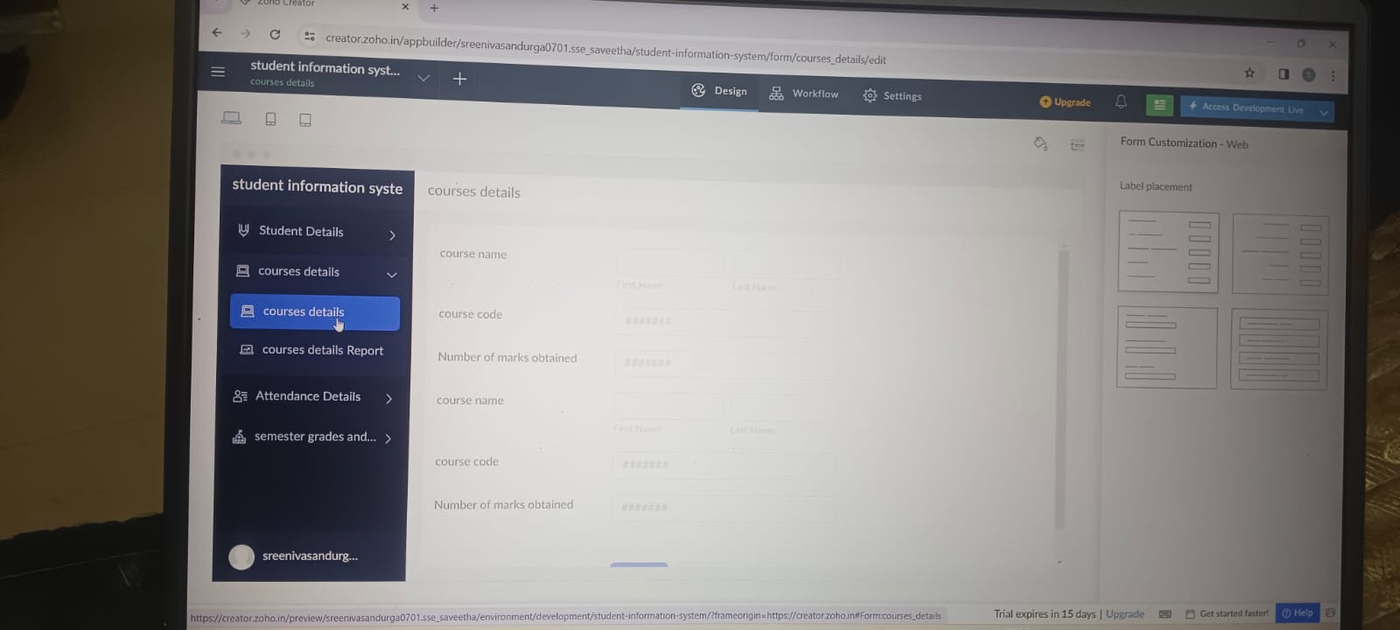

STEP:4: CRAETE A APLICATION FORM FOR THE SEMESTER AND REPORT.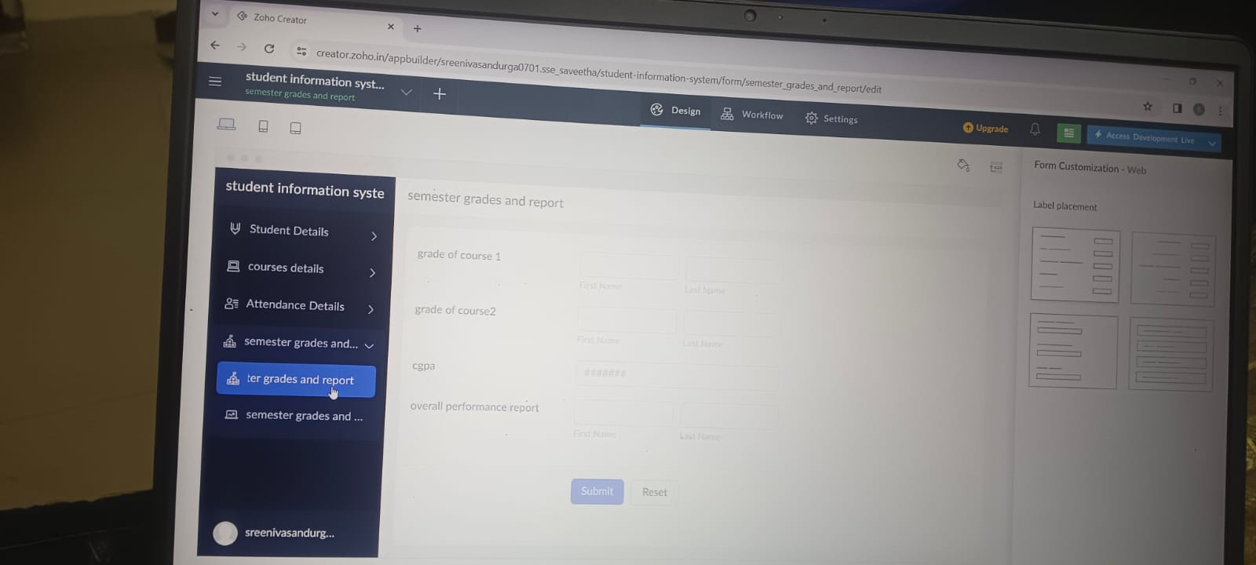

STEP:5: CREATE A APPLICATION FORM FOR THE STUDENT RESULT / REPORT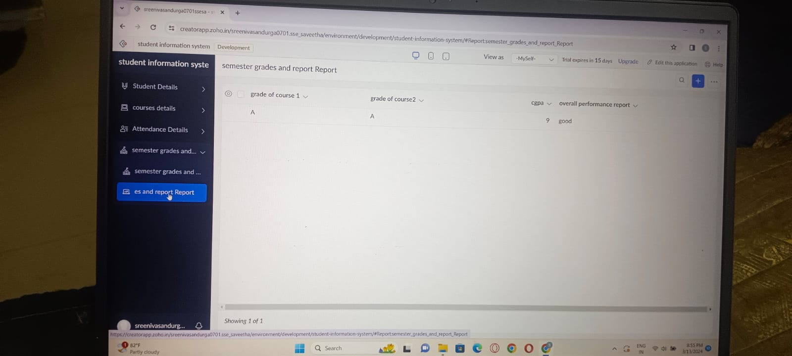

RESULT: THUS,THE PROGRAM FOR THE STUDENT INFORMATION SYSTEM HAS BEEN EXCEUTED SUCCESSFULLY.